AIGC 5003 Machine Learning Cloud Computing  
Lab One

* Create a new instance in a public subnet.
* Install boto3 python library on it.
* Query S3 bucket and running instances programmatically from the inside of that instance.

The Architecture

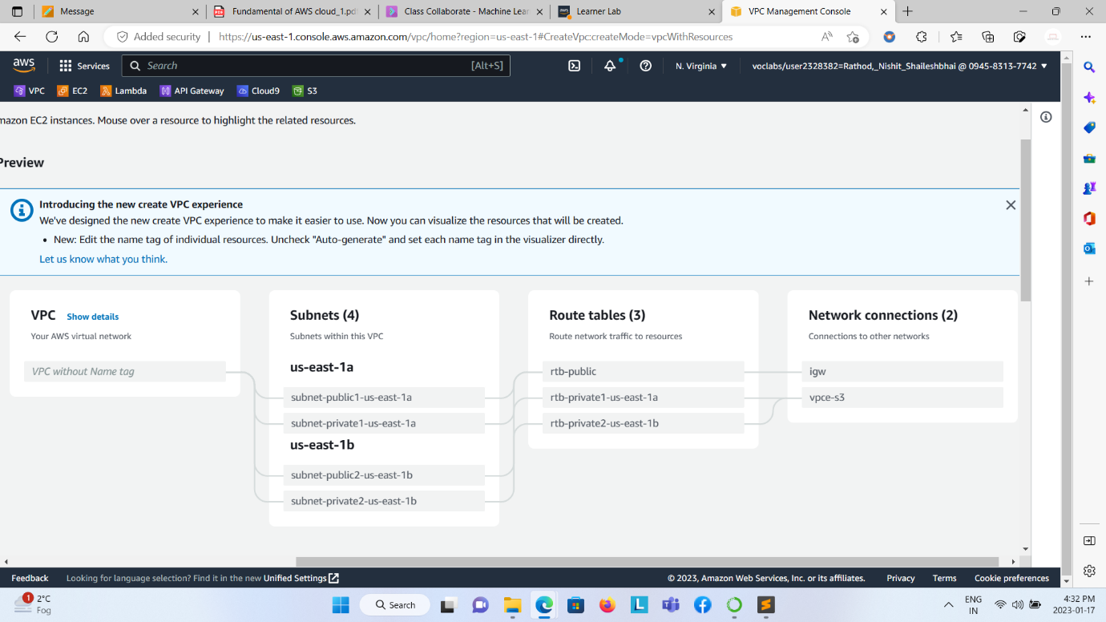

VPC

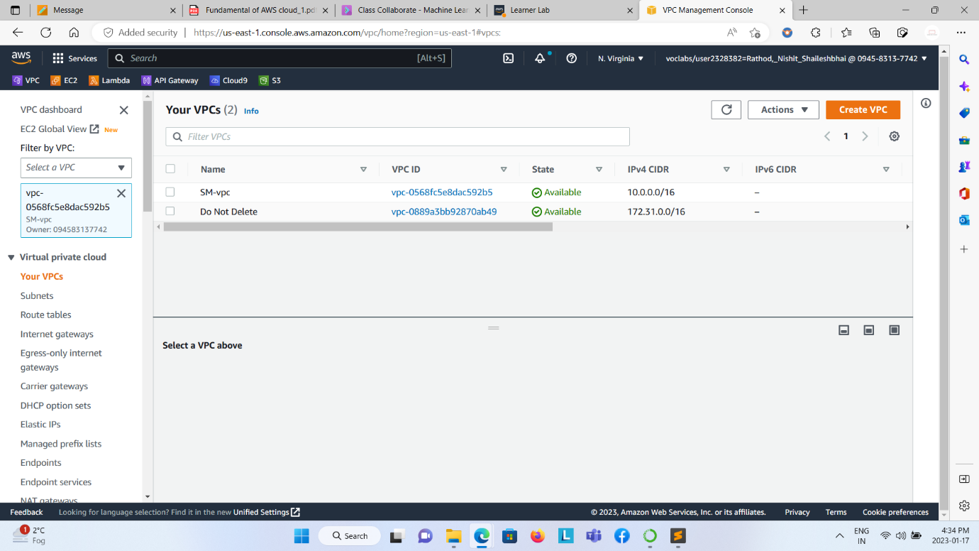

Subnets

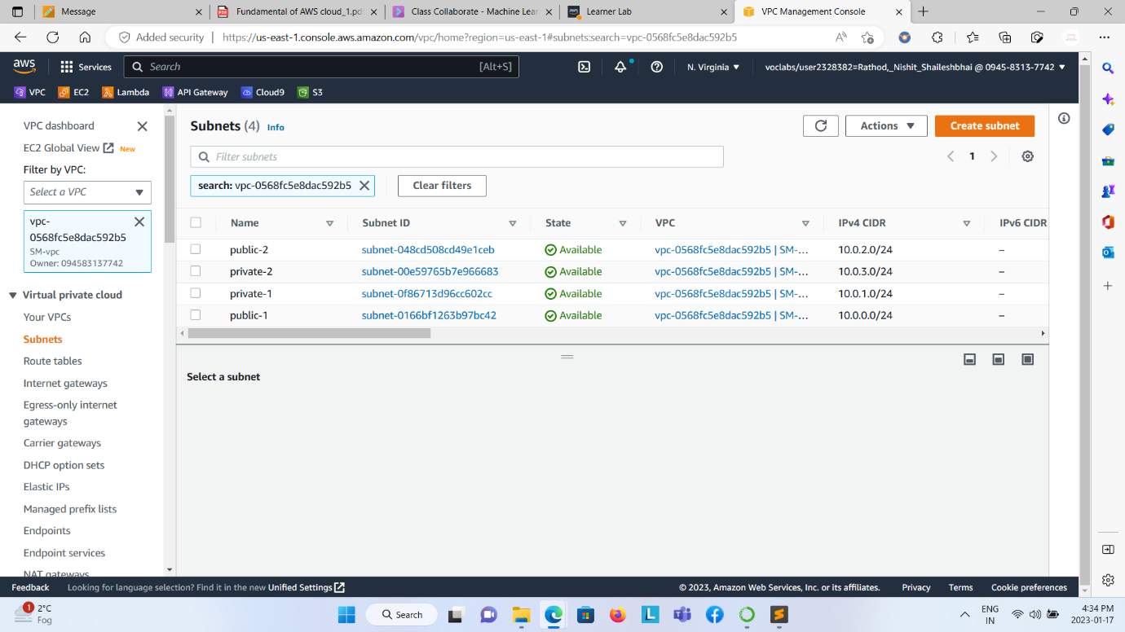

Route Tables

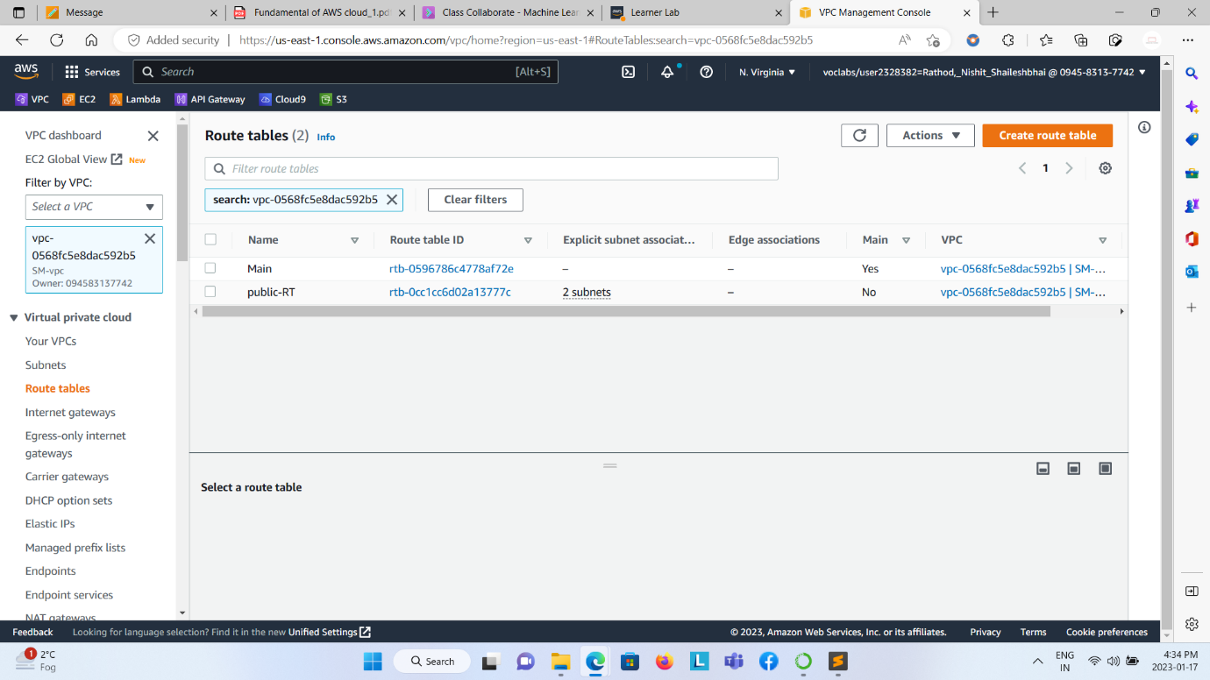

Internet Gateways

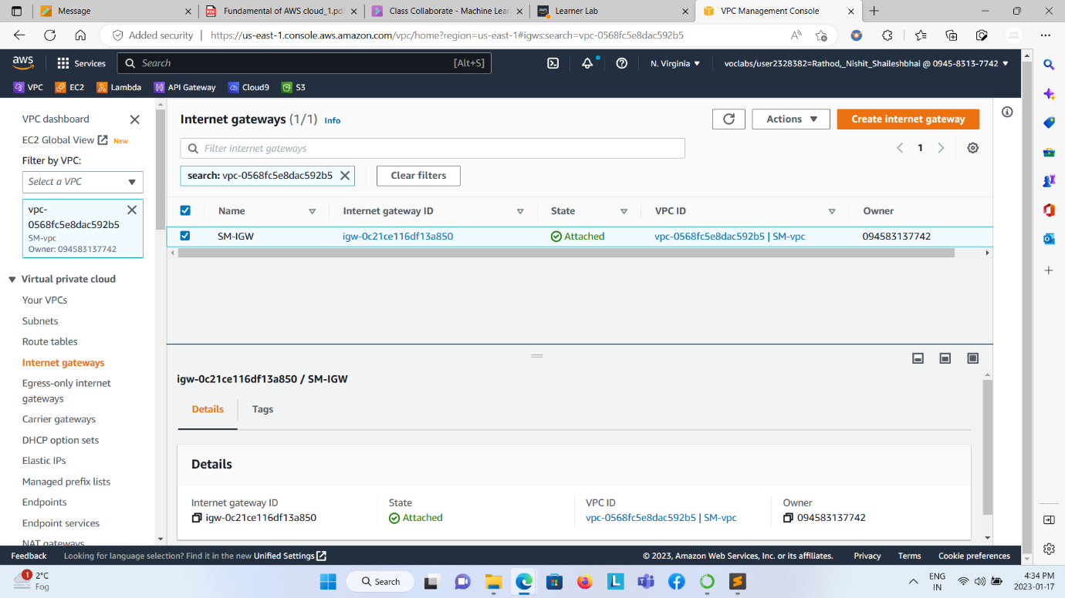

EC2 Instances  
  
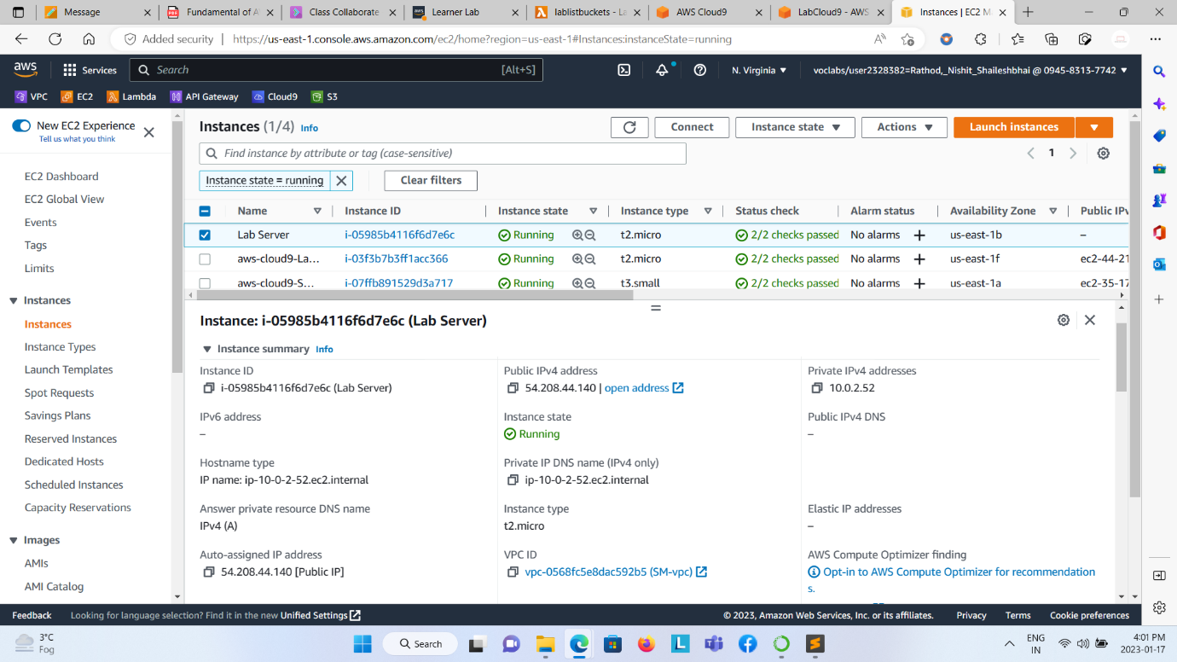  
  
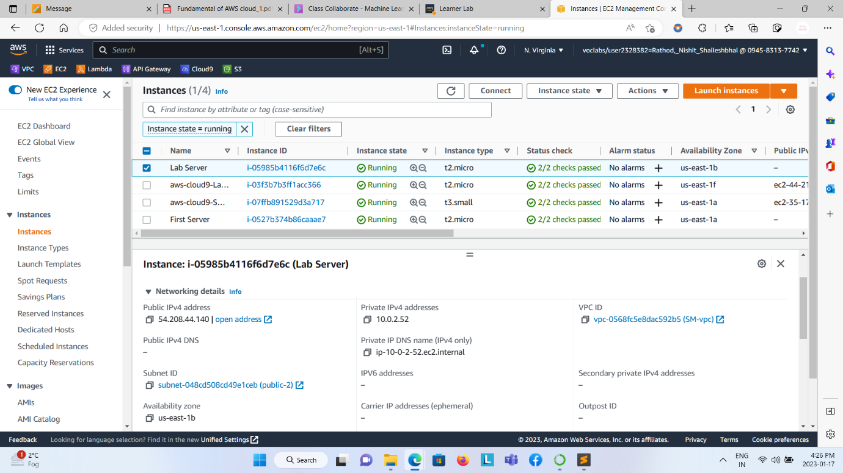

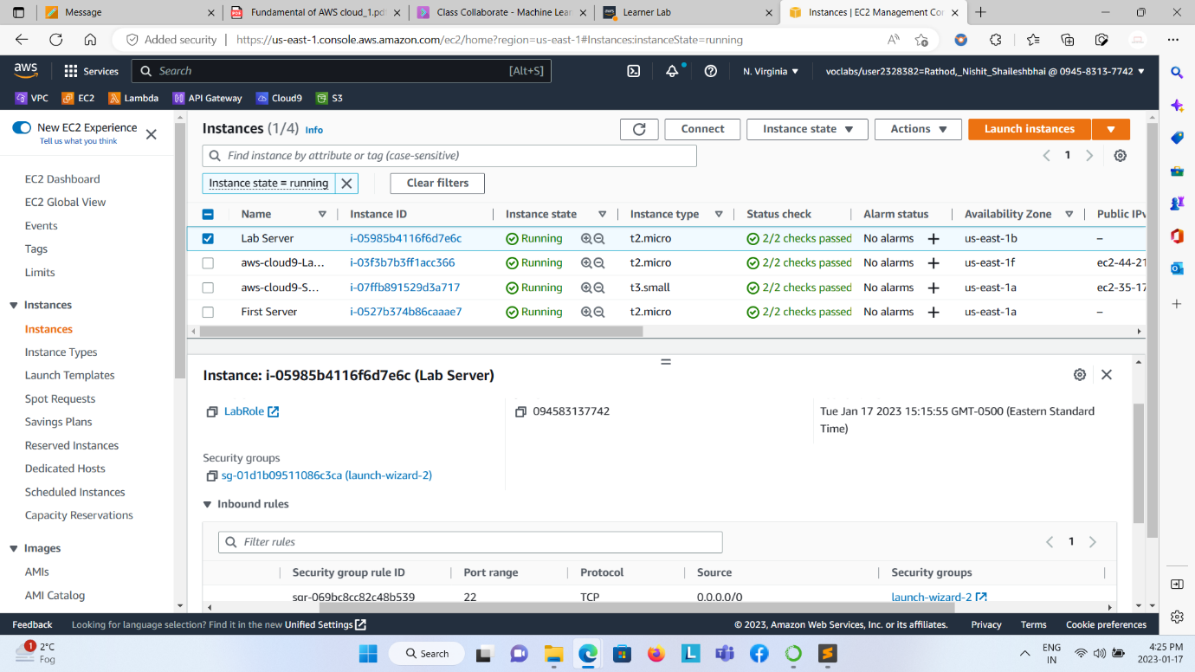

Lambda Function: lablistinstances and lablistbuckets  
  
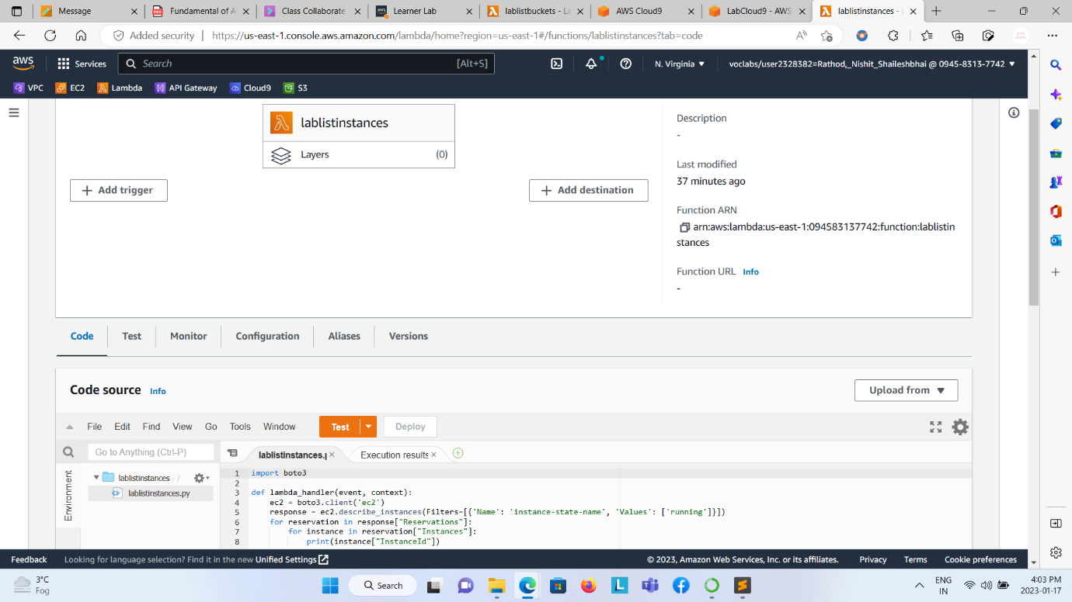  
  
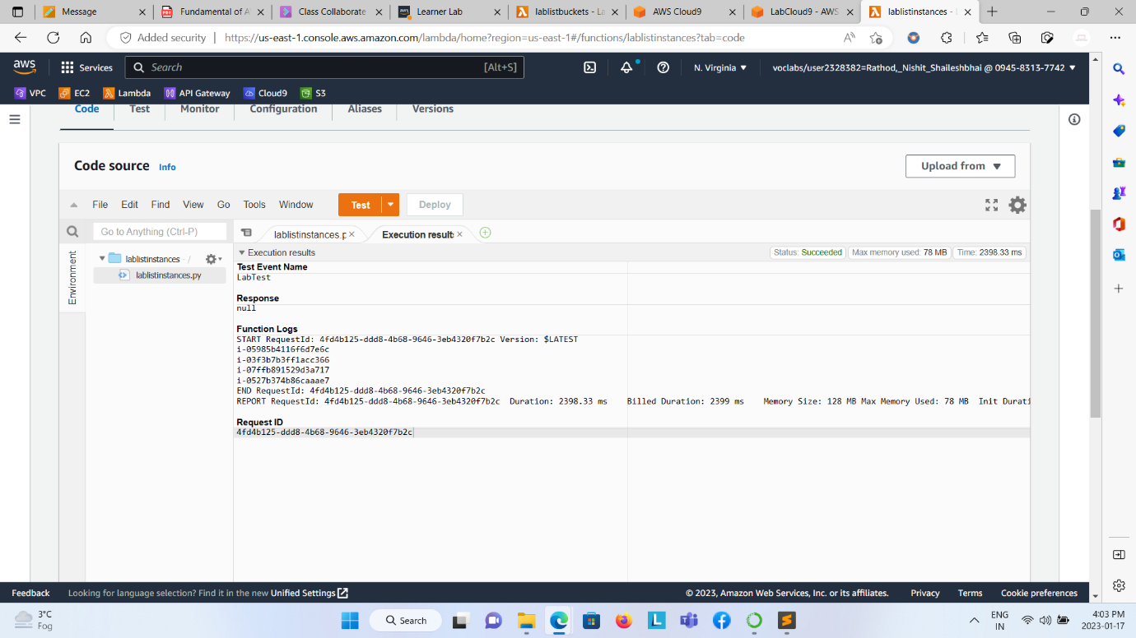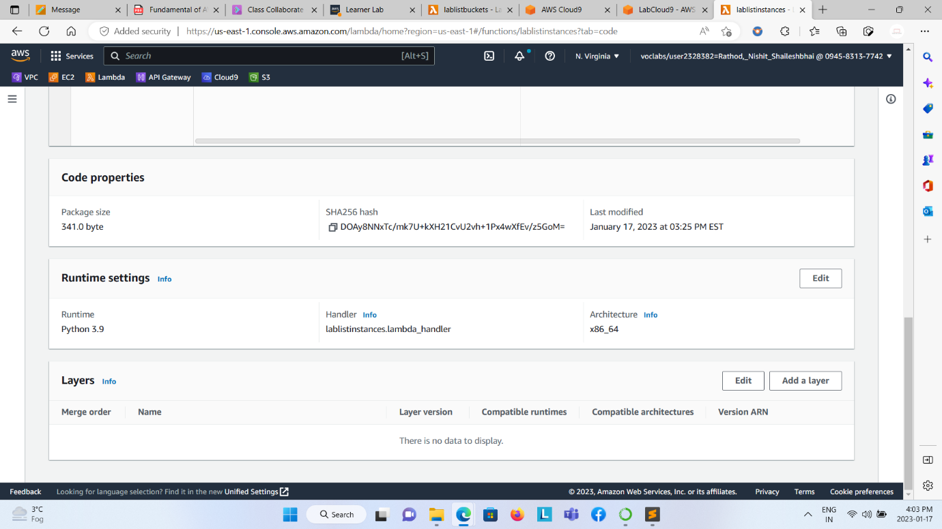  
  
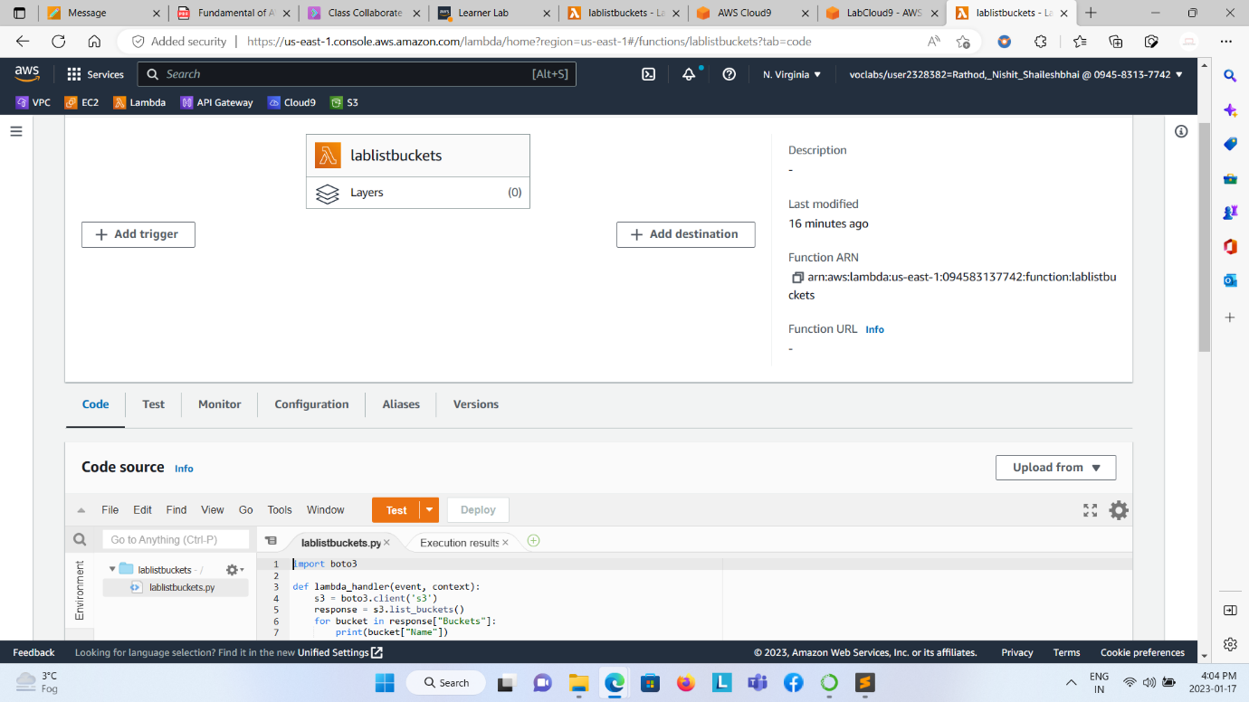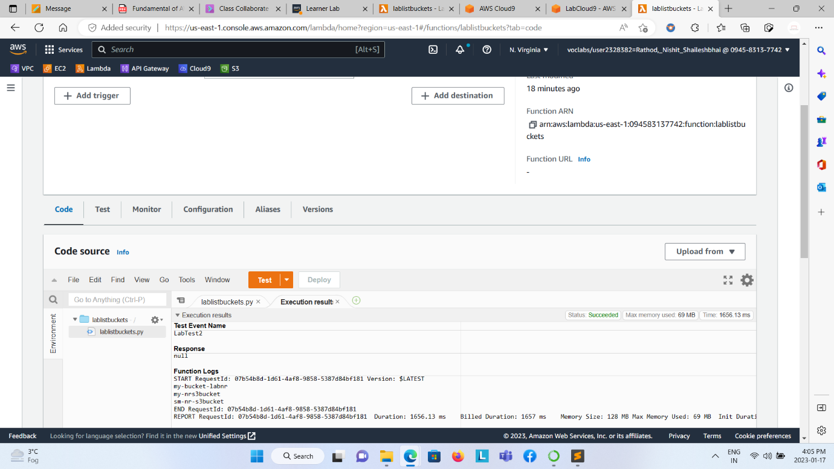  
  
Created Cloud9 environment  
Installing Boto3, Running ec2-instance.py, lablistbucketscloud9.py, listbuckets.py, and lablistinstances.py files by “python filename.py code”   
  
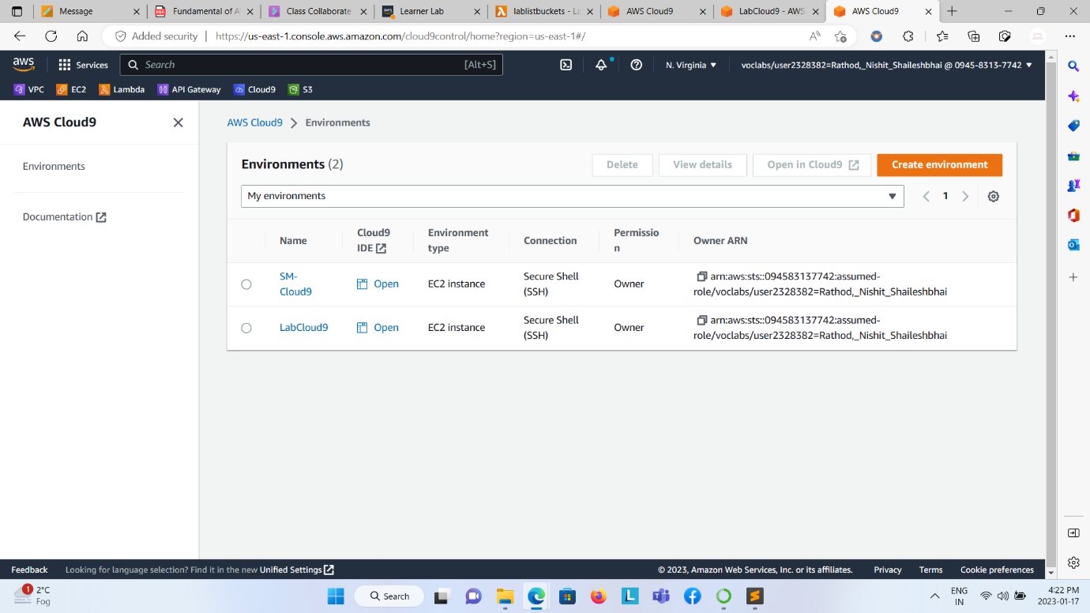  
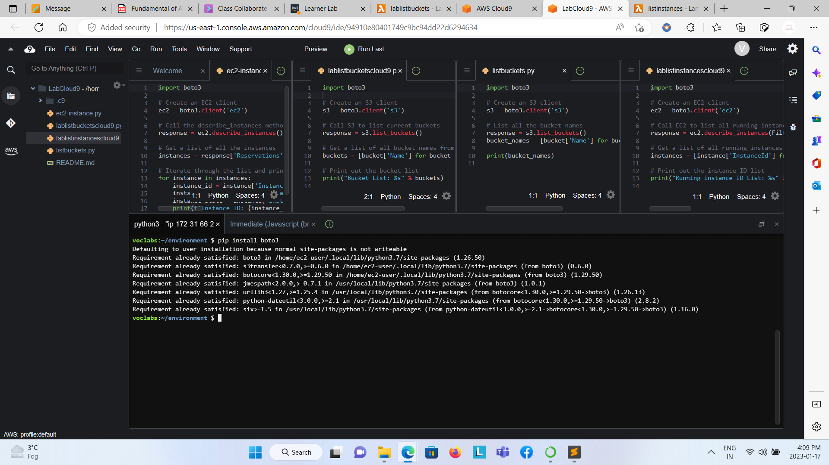  
  
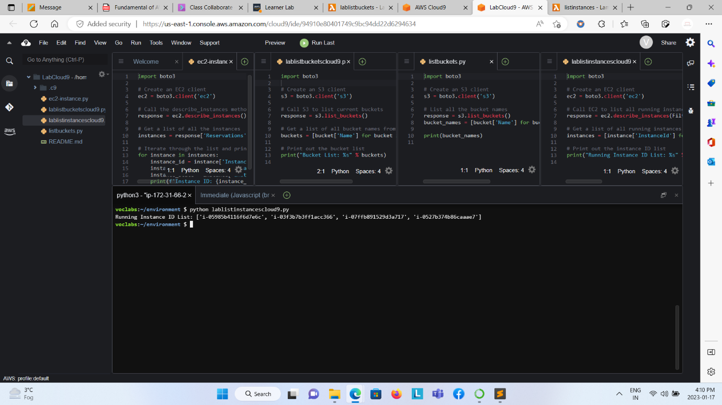

Created buckets on Cloud9 AWS Commandline interface by “aws s3 mb s3://my-new-bucket” code.  
  
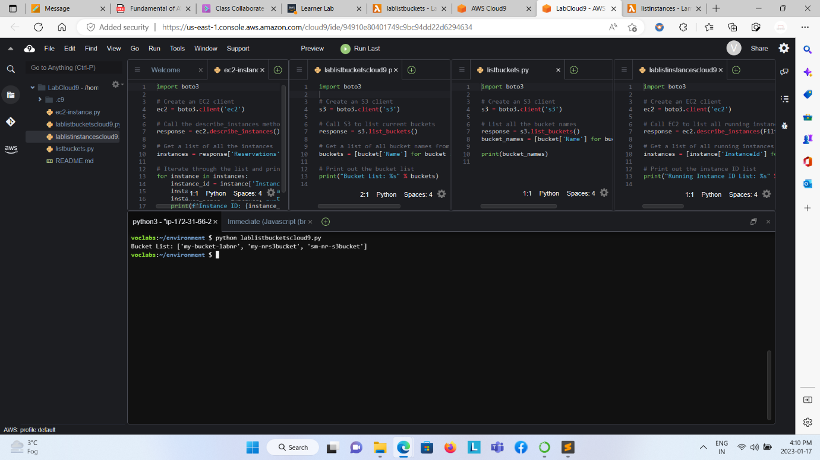  
  
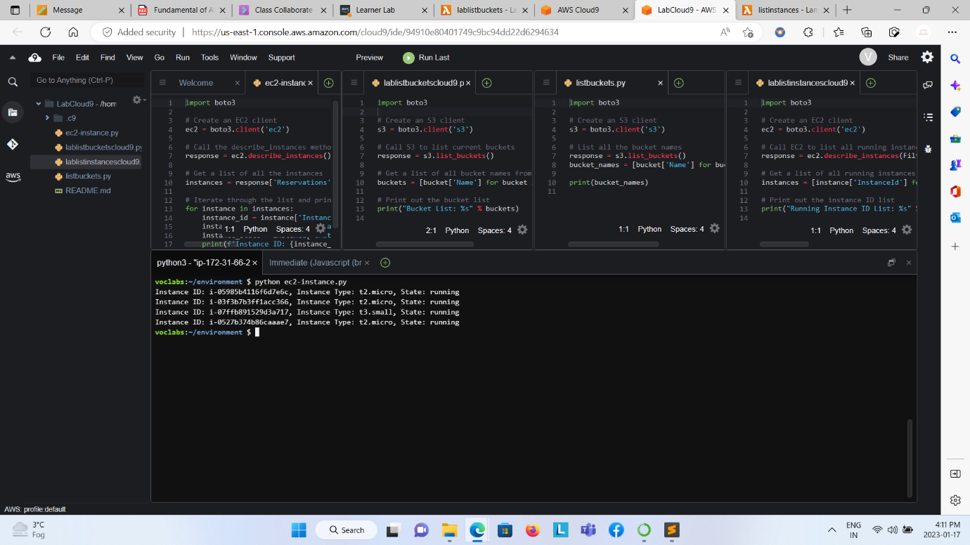  
  
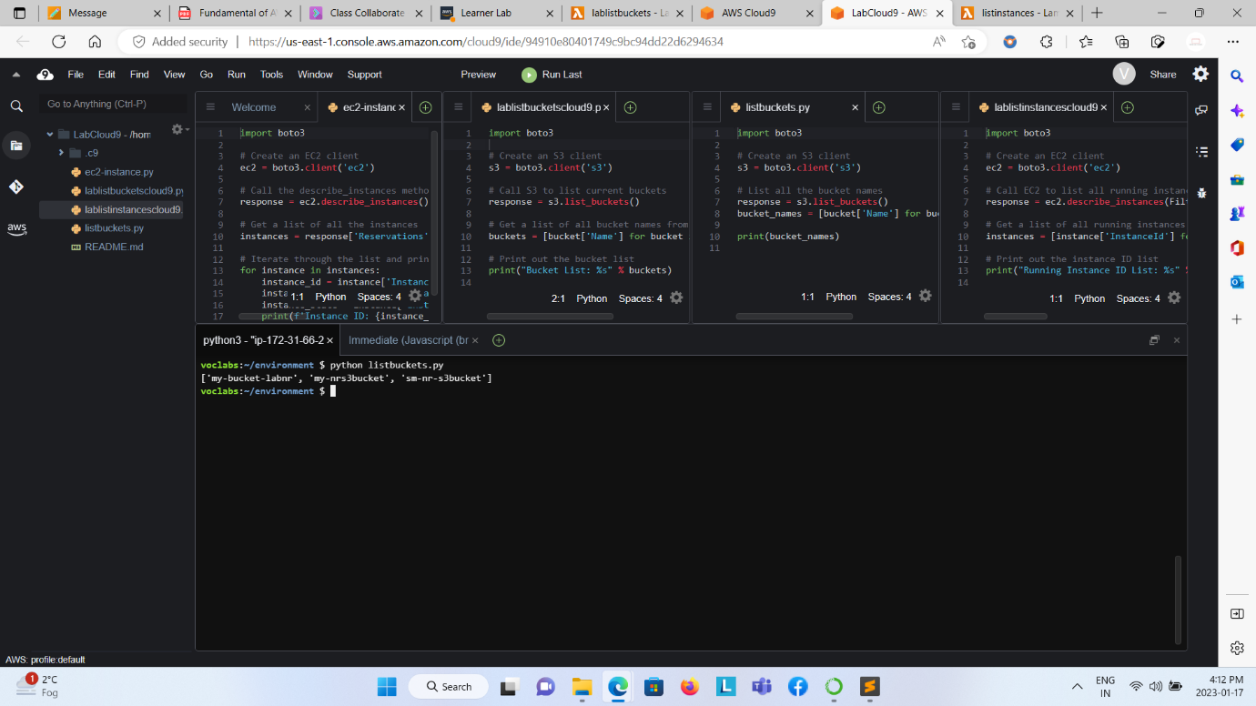

S3 Bucket created and loaded Image:  
  
